Courses

Courses are the spaces on Moodle where [teachers](https://docs.moodle.org/31/en/Teacher) add learning materials and activities for their students. Courses may be created by [admins](https://docs.moodle.org/31/en/Administrator), [course creators](https://docs.moodle.org/31/en/Course_creator) or [managers](https://docs.moodle.org/31/en/Manager). Teachers can then add the content and re-organise them according to their own needs.

# Module: Course Categories

## Feature: Assigning users a role in a course category

To assign users a role in a course category, see Module: [Category enrolments](https://docs.moodle.org/31/en/Category_enrolments).

# Module: Category Enrolments

## Feature: Enrolling users to a category

1. Go to the category into which you wish to enrol users. Note: You need to have category rights (manager or administrator)
2. In the Administration block, click Assign roles. *“Feature: Enrolling Users to a category”.* The list of possible roles you can assign will appear:

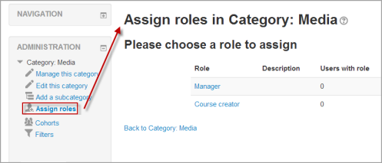

1. You should click on the desired role in order to start assigning users for this role inside this category. The number of user with role in the table above will be updated automatically after the assignments. *“feature: Assigning teachers or students to a category”*

NOTE: The roles you see here are roles which have been assigned at the category context and which you are able to assign i.e. you have to go to Roles and Permissions > Assigning Roles > Context and Roles > Course Category Context.

# Module: Roles and Permissions

## Feature: Assigning Roles > Context and roles

* In Moodle, apart from the site administrator, users do not normally have a global, site-wide role. In other words, even though you may be a teacher offline, when you are in Moodle you could have a teacher role in the course you teach in but a student role in another course where you are studying for a diploma. There are a few exceptions but this is generally the case.
* Because of the way Moodle works, assigning roles is done for a particular context. A site and course are examples of two different contexts. When you create a new role or tweak a pre-existing role, you are asked in which context(s) you want the role to be assigned:

# 

## Feature: Course Category context

* Users may be enrolled in the category to save enrolling them in each individual course in that category.
* Used in module: [Category enrolments](https://docs.moodle.org/31/en/Category_enrolments) as explained above.

# Problem

Suppose when you use the feature: enrolling users to a category, the list of roles is empty as shown below:

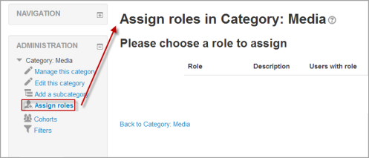

You should use feature: Context and Roles > Course Category Context. However, to do so you will have to go to a different page in a different module.

Write a feedback to request an enhancement, which is adding a permissions link in the Category administration block to improve the usability, and reduce the navigation steps needed to finish the task.